Bringing an Agentic AI Mesh‑style governance to non-technical stakeholders with n8n

Agentic workflows are reshaping how businesses add intelligence to day‑to‑day processes. From automated ticket triage in SaaS help desks to dynamic contract review in legal ops, the ability to let an LLM‑powered agent act on real‑time data is a game‑changer.

* Customer support – A single agent can answer FAQs, flag complex tickets, and hand off to a human only when needed.
* Legal & compliance – An agent parses clauses, flags risks, and drafts summaries in seconds.
* Marketing automation – Agents personalize email copy based on customer segments, boosting engagement rates.
* Finance & operations – Agents reconcile invoices, predict cash‑flow gaps, and auto‑generate reports.

These use‑cases illustrate the same pattern: AI‑powered decision logic wrapped in a workflow that can be edited by non‑technical stakeholders.

In a prior post we described the Agentic AI Mesh architecture (<https://medium.com/quantumblack/how-we-enabled-agents-at-scale-in-the-enterprise-with-the-agentic-ai-mesh-architecture-baf4290daf48>), principles to manage such complexity as such solution scale in productiion, interacting with other core systems of record and agentic systems. ARK is an agentic runtime we did develop that implements such principles with agentic components (tools, models, other CRDs..) discoverabiliy, reusability, scalibility and orchestration at its core.

Key Mesh principles:

|  |  |
| --- | --- |
| PRINCIPLE | HOW ARK IMPLEMENTS IT |
| Discoverability | Agents, models, evaluators are exposed as Kubernetes CRDs; any system can list or query them. |
| Reusability | A single agent definition can be referenced by dozens of workflows, APIs, or scheduled jobs. |
| Scalability | Pods are autoscaled per workload; evaluation capacity is independent from agent execution. |
| Orchestration | The ARK Operator guarantees consistent state and manages cross‑resource dependencies. |

ARK is our open-source Kubernetes runtime that brings these principles to life bringing advanced governance and control on the platform layer. Since any component in ARK is exposed through APIs, it opens up the ability to have underlying resources (agents, models, mcp servers, tools, evaluations..) consumable by third party services, frontend and even low-code workflow editors such as n8n, eventually exposing powerful and intelligent agentic capabilities to Non‑technical stakeholders can tweak routing, set quality thresholds, and add new integrations—all in the UI while leveraging 400+ pre‑built integrations (CRM, ticketing, databases, communication platforms) in n8n.

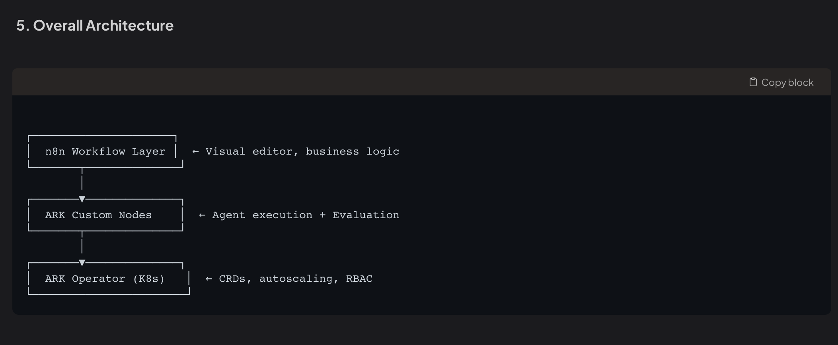

The **three‑layer stack** lets platform teams own the AI runtime while business users own the workflows. Each layer can evolve independently, yet they remain tightly coupled through well‑defined APIs.

In the following example, we illustrate such approach for a customer support flow (explain further what this is, how recurring this process is in the industry and how agents can be valuable with proper governance from fintech to large corporations).

Here we can add the screenshot of the full and describe each step

1. Webhook Trigger – A new support ticket lands in the CRM.
2. ARK Agent Node – The ticket text is sent to the support-response-agent (Explain that the agent is available in Ark, and we can show a screenshot showing a list of reusable agents).
3. ARK Evaluation Node – The agent’s reply is evaluated against the support-quality-evaluator (explain that we leverage the evaluation capabilities of Ark).
4. IF Node –
   1. Score ≥ 0.8 → Send response to the customer via email.
   2. Score < 0.8 → Push draft to a Slack channel for human review, attach evaluation reasoning.
5. Post‑Action – notify outcome to support Channels (i.e Slack), update ticket status in a CRM, and optionally trigger a follow‑up workflow.

**Screenshots (placeholders) – We can also show two other custom nodes like Ark Team and Ark Model, explain that more advanced workflows can be eventually achieved out of this.**

End with takeways and benefits Takeaways, Benefits & Unlocks

BENEFIT WHAT IT ENABLES

Reusable agent library One agent definition powers multiple workflows, APIs, and scheduled jobs.

Independent scaling AI pods and evaluation pods scale separately, preventing bottlenecks.

Governance via GitOps Every change is versioned, auditable, and rollback‑ready.

Rapid business iteration Non‑technical users adjust thresholds or add integrations without code.

Enterprise‑grade quality gates Mis‑aligned or low‑quality outputs are caught before reaching customers.

Call to Action

Start with a single agent (e.g., a FAQ responder) and one workflow (ticket triage). Once you’re comfortable, add an evaluator, tighten thresholds, and expose the agent to other business systems. The result? Scalable, governed, and composable AI that grows with your organization—whether you’re a startup or a Fortune 500.